Инфа на главной странице  
Often called “The Most Beautiful Woman in Film,” Hedy Lamarr’s beauty and screen presence made her one of the most popular actresses of her day.

She was born Hedwig Eva Maria Kiesler on November 9, 1914 in Vienna, Austria. At 17 years old, Hedy starred in her first film, a German project called *Geld auf der Strase*. Hedy continued her film career by working on both German and Czechoslavakian productions. The 1932 German film *Exstase* brought her to the attention of Hollywood producers, and she soon signed a contract with MGM.

Once in Hollywood, she officially changed her name to Hedy Lamarr and starred in her first Hollywood film, *Algiers* (1938), opposite Charles Boyer. She continued to land parts opposite the most popular and talented actors of the day, including Spencer Tracy, Clark Gable, and Jimmy Stewart. Some of her films include an adaptation of John Steinbeck’s *Tortilla Flat* (1942), *White Cargo* (1942), Cecil B. DeMille’s *Samson and Delilah* (1949), and The Female Animal (1957).

Filmography можешь отсюда 2-3 фильма взять на гланую страницу  
<https://www.hedylamarr.com/about/filmography/>

Inventor  
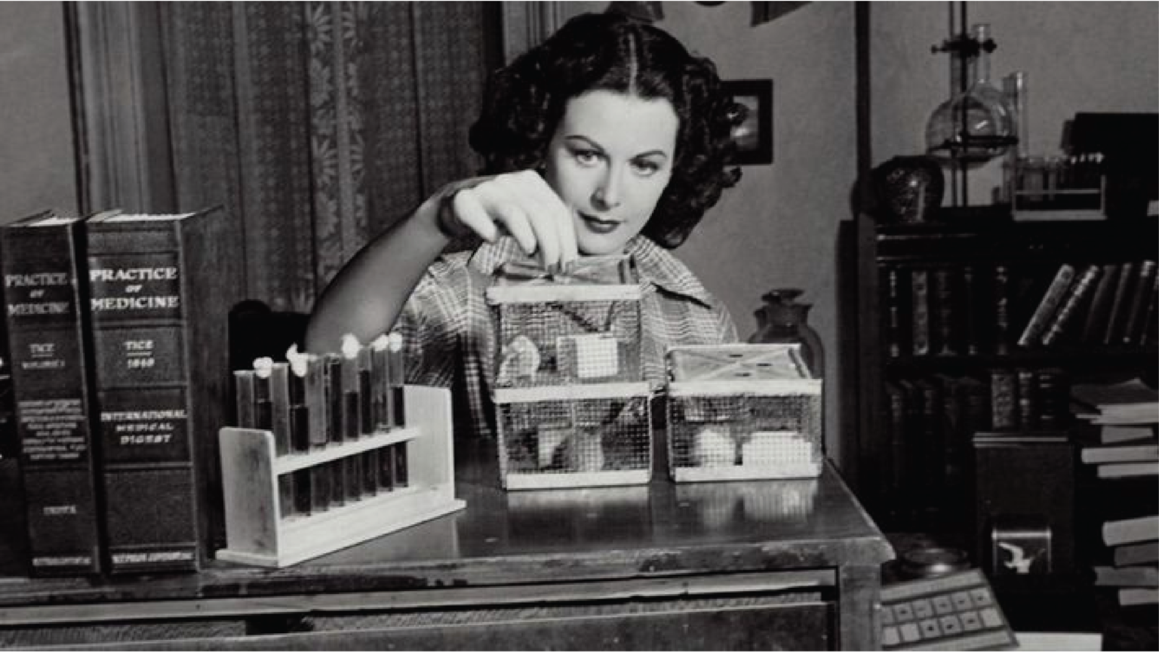

* «Системы секретной связи»
* [*frequency-hopping spread spectrum*](https://it.wikipedia.org/wiki/Frequency-hopping_spread_spectrum) .

## **Knowledge Organization**

<https://docs.google.com/document/d/1PH6LHb-je4152xxLe3DGtJxfBR2iFc9qLM4qaPaflmw/edit?tab=t.0> Это я тебе скинул уже в тг